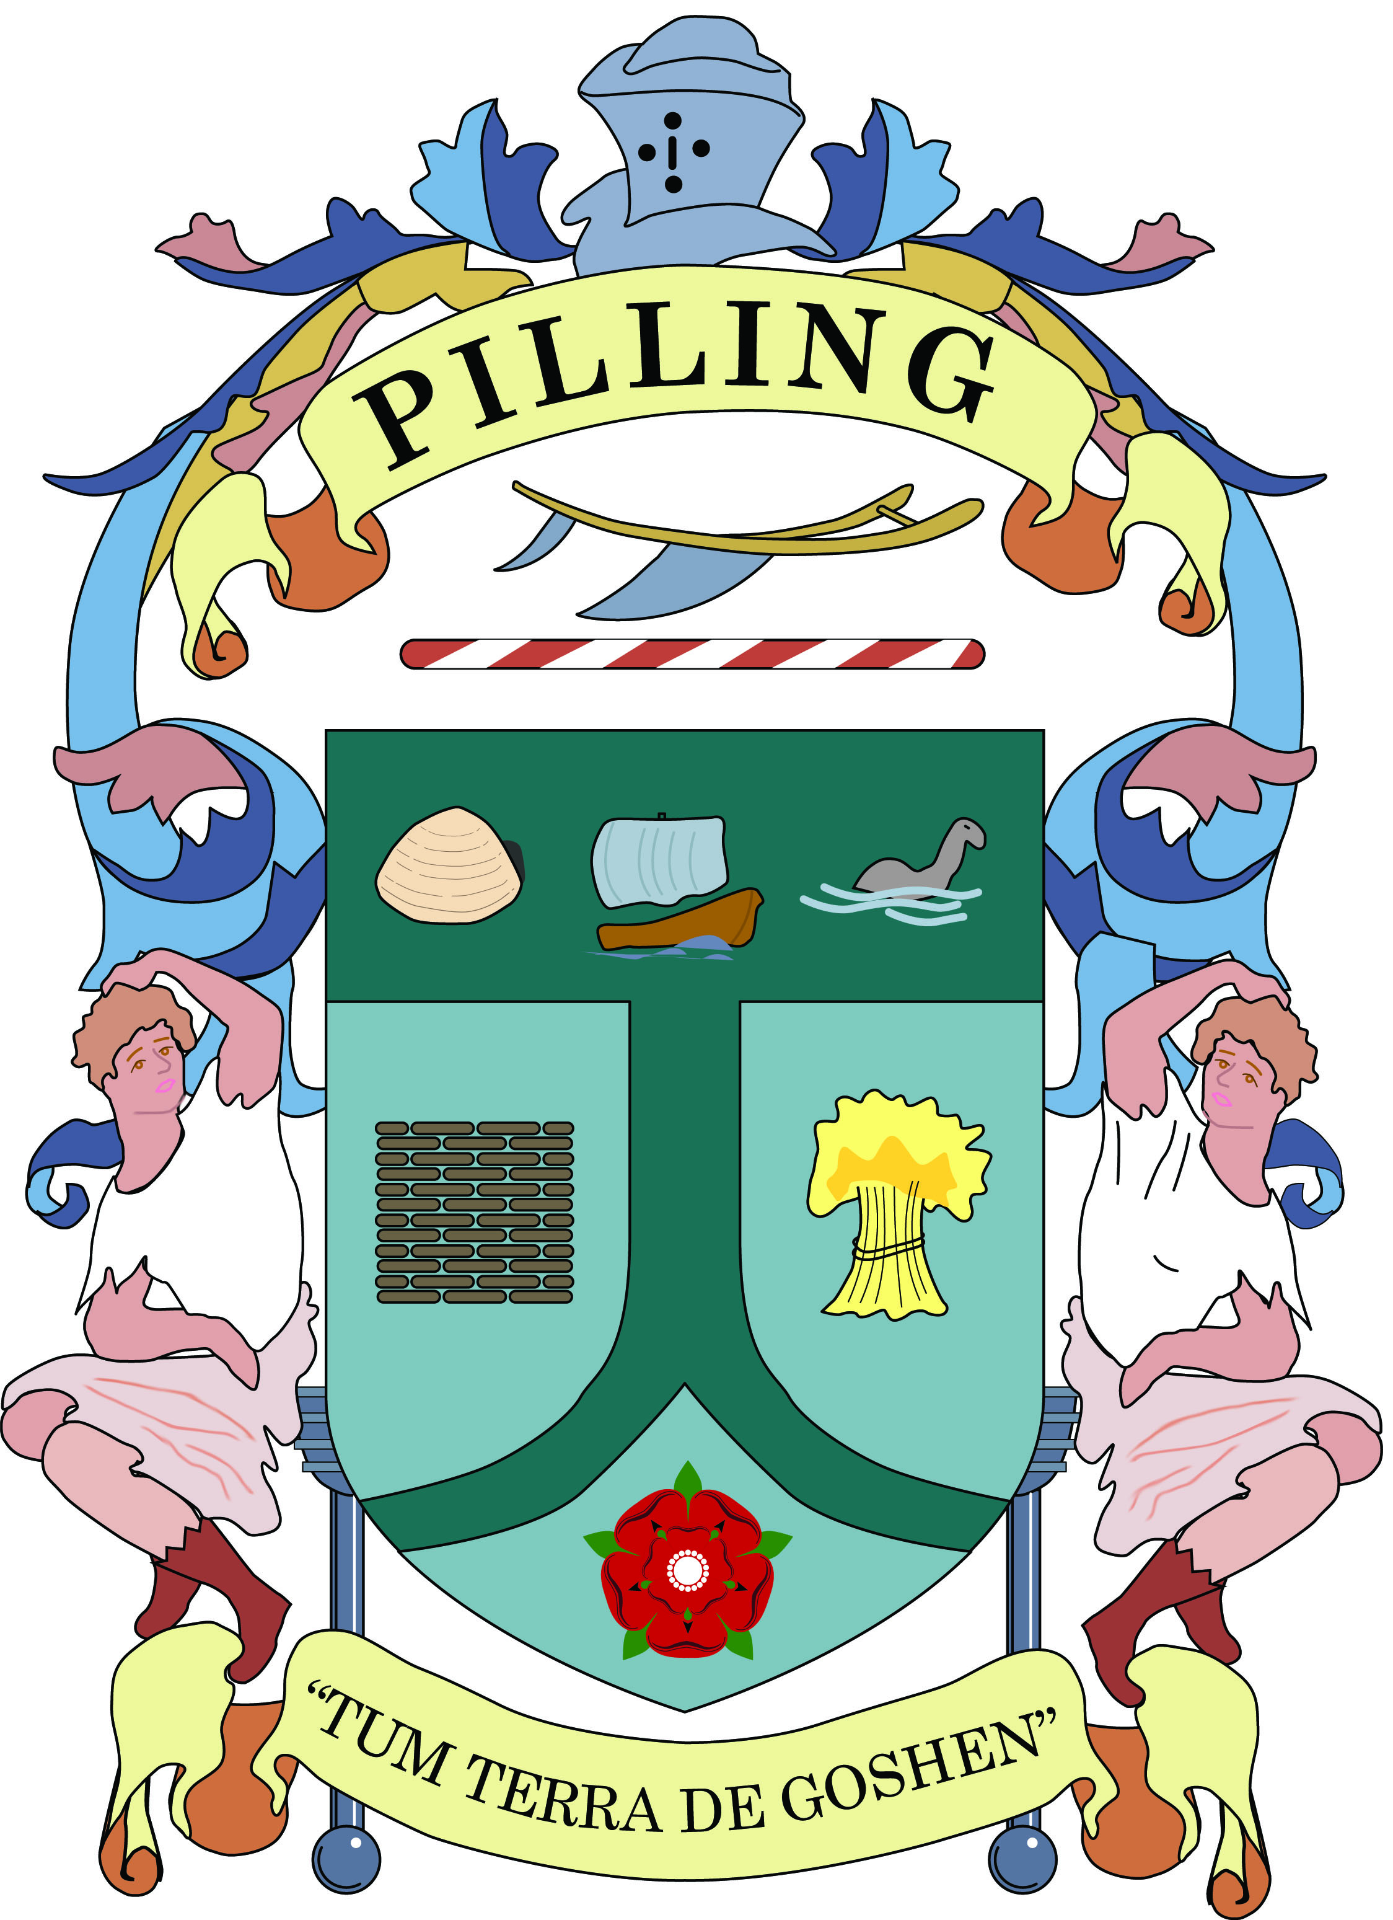**PILLING PARISH COUNCIL**

**JOB DESCRIPTION**

**CLERK AND RESPONSIBLE FINANCIAL OFFICER**

**Overall Purpose**

Responsible for the effective day to day management of the Parish Council, ensuring compliance with all legal and other requirements governing the running of the Council and providing independent, objective and professional advice and support.

The Clerk will be the Council’s Proper Officer (the person legally responsible for actioning the decisions of the Council) and the Responsible Financial Officer (legally responsible for the financial management of the Council).

**Main Duties and Responsibilities**

**Meetings**

1. Prepare, in consultation with the appropriate councillors, and issue comprehensive agendas for meetings of the Parish Council and Committees. Attend such meetings, prepare minutes for approval and act on decisions made.
2. Issue notices and prepare agendas and minutes for the Annual Parish Meeting: attend the assemblies of the Annual Parish Meeting and to implement the decisions made at the assemblies that are agreed by the Council.

**Finance and Audit**

1. Manage the Council’s finances effectively, monitoring and balancing the accounts and preparing regular reports on the Council’s financial position.
2. Place orders, receive and report on invoices for goods and services to be paid for by the Council and ensure such accounts are met. Issue invoices on behalf of the Council for goods and services and ensure payment is received.
3. Ensure that the correct financial records are kept and internal controls in place to support both internal and external audit regimes.
4. Ensure that proper employment records are kept complying with legislative requirements, liaising with the Council’s payroll provider to ensure salaries and pensions are correctly administered and paid.
5. Research and bring forward opportunities to apply for grants to support the work of the Council.

**Administration**

1. Receive correspondence and documents on behalf of the Council and, following known policy of the Council, either respond on its behalf or bring such items to the attention of the Council. Issue correspondence as a result of instructions of, or the known policy of the Council.

**Governance**

1. Ensure that the Council has the appropriate governance and internal control documents, policies and procedures and that these are kept under regular review and up to date.
2. Monitor implemented policies to ensure they are achieving the desired result and, where appropriate, suggest modifications.
3. Ensure that the Council’s obligations in relation to health and safety are properly met.
4. Ensure that all operations of the council are timely and procedurally correct.
5. Take appropriate action to ensure that all Council elections and co-options are undertaken in accordance with legal requirements.

**Staff Management**

1. Supervise any other members of staff as their line manager in keeping with the policies of the Council and undertake all necessary activities in connection with the management of salaries, conditions of employment and work of other staff.

**Communications**

1. Keep the Council’s website up to date and manage the Council’s social media presence, working with the Communications Committee and produce the Pilling Newsletter twice per year with articles supplied by councillors and those of interest to residents.
2. Collaborate with Councillors in the preparation and issue of Press releases and other media engagement, monitoring outcomes. Work cooperatively with the media to promote the role and a positive public perception of the Council, as directed.

**Continuous Professional Development**

1. Study reports and other data on the Council’s activities and on matters relating to those activities as directed. Where appropriate, discuss such matters with administrators and specialists in particular fields and produce reports for circulation and discussion by the Council.
2. Attend training courses or seminars on the work and role of the Clerk as required by the Council.
3. Work towards the achievement of the status of Qualified Clerk as a minimum requirement for effectiveness in the position of Clerk to the Council.
4. Continue to acquire the necessary professional knowledge required for the efficient management of the affairs of the Council

**Other**

1. To act as the representative or spokesperson of the Council as required.
2. Build relationships and work in collaboration with other village organisations such as Pilling Village Hall, Pilling in Bloom, Pilling Coffee Feast, Pilling Churches and Schools.
3. There are nine defibrillators in the Parish maintained and checked monthly. They are signed up to The Circuit, to allow access by North West Ambulance Service
4. Undertake such other duties which are commensurate with the post as may be reasonably required by the Clerk or the parish council

April 2024